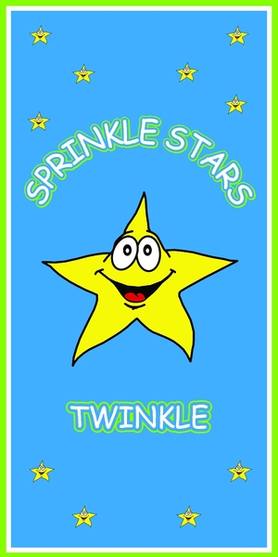
Friendly Reminder

Sprinkle Stars Twinkle Daycare

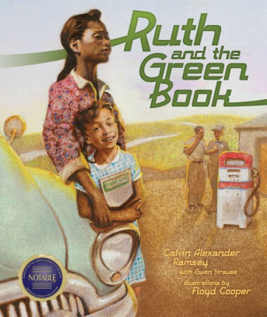
“I have a Dream” Family Evening
Event
Featuring Playwright and Author
Calvin Ramsey
Also
Portraits of the
First Sprinkle Stars Twinkle Class
by Raymond Rios
and Students’ Reading Excerpts of “I have a Dream” Speech
January 18, 2019

4:00 – 6:00 p.m.
Light Refreshments

